Assignment No. 02
Title: Construct an expression tree from postfix expression and perform recursive and non- recursive traversals.

Introduction:
Expression Tree:
An expression tree is a binary tree in which each internal node corresponds to the operator and each leaf node corresponds to the operand.
- Leaf nodes → Operands (variables or constants)
- Internal nodes → Operators (+, −, ×, /, etc.)
It is mainly used in:
- Compiler design
- Expression evaluation
- Parsing arithmetic expressions

Structure of Expression Tree:
- It is a binary tree.
- Every operator has
  - Left Child Left Operand
  - Right Child Right Operand
- Operands are always leaf nodes.

Expression trees can be constructed from:
- Infix notation → a + b
- Prefix notation → + a b
- Postfix notation → a b +

Operator Precedence Maintained in Expression Tree
From highest to lowest:
- () → Parentheses
- ^ → Exponentiation
- * / % → Multiplication, Division, Modulus
- + - → Addition, Subtraction

Pseudocodes:

1. Create Node
FUNCTION create(data)
CREATE new node called root
SET root.data = data
SET root.l = NULL
SET root.r = NULL
RETURN root
END FUNCTION

2. Inorder Recursive Traversal
FUNCTION inorder(root)
IF root is not NULL THEN
CALL inorder(root.l)
PRINT root.data
CALL inorder(root.r)
END IF
END FUNCTION

3. Preorder Recursive Traversal
FUNCTION preorder(root)
IF root is not NULL THEN
PRINT root.data
CALL preorder(root.l)
CALL preorder(root.r)
END IF
END FUNCTION

4. Postorder Recursive Traversal
FUNCTION postorder(root)
IF root is not NULL THEN
CALL postorder(root.l)
CALL postorder(root.r)
PRINT root.data
END IF
END FUNCTION

5. Construct Tree
FUNCTION constructTree(exp)

CREATE empty stack st

FOR each character ch in exp

IF ch is operand (letter or digit) THEN
CREATE node using create(ch)
PUSH node into stack

ELSE // ch is operator

CREATE node using create(ch)

SET node.r = TOP element of stack
POP stack

SET node.l = TOP element of stack
POP stack

PUSH node into stack
END IF

END FOR

RETURN TOP element of stack

END FUNCTION

6. Inorder Non-Recursive Traversal
FUNCTION inorderNR(root)

CREATE empty stack st
SET current = root

WHILE current is not NULL OR stack is not empty DO

WHILE current is not NULL DO
PUSH current into stack
SET current = current.l
END WHILE

SET temp = TOP element of stack
POP stack

PRINT temp.data

SET current = temp.r

END WHILE

END FUNCTION

7. Preorder Non-Recursive Traversal
FUNCTION preorderNR(root)

CREATE empty stack st
PUSH root into stack

WHILE stack is not empty DO

SET temp = TOP element of stack
POP stack

PRINT temp.data

IF temp.r is not NULL THEN
PUSH temp.r into stack
END IF

IF temp.l is not NULL THEN
PUSH temp.l into stack
END IF

END WHILE

END FUNCTION

Algorithms:
1. Create Node
Step 1: Start
Step 2: Allocate memory for a new node called root
Step 3: Set root.data = data
Step 4: Set root.l = NULL
Step 5: Set root.r = NULL
Step 6: Return root
Step 7: Stop

2. Construct Tree
Step 1: Start
Step 2: Create an empty stack st
Step 3: For each character ch in expression exp, repeat Steps 4–10
Step 4: If ch is an operand (letter or digit), then follow step 6
Step 5: Create a node using CREATE_NODE(ch)
Step 6: Push the node into stack
Step 7: Else (ch is an operator) follow step 8 to 11
Step 8: Create a node using CREATE_NODE(ch)
Step 9: Pop top element of stack and assign it to node.r
Step 10: Pop next top element and assign it to node.l
Step 11: Push node into stack
Step 12: End For loop
Step 13: Return the top element of stack
Step 14: Stop

3. Inorder Recursive Traversal
Step 1: Start
Step 2: If root ≠ NULL, then do Steps 3–5
Step 3: Call INORDER(root.l)
Step 4: Print root.data
Step 5: Call INORDER(root.r)
Step 6: Stop

4. Preorder Recursive Traversal
Step 1: Start
Step 2: If root ≠ NULL, then do Steps 3–5
Step 3: Print root.data
Step 4: Call PREORDER(root.l)
Step 5: Call PREORDER(root.r)
Step 6: Stop

5. Postorder Recursive Traversal
Step 1: Start
Step 2: If root ≠ NULL, then do Steps 3–5
Step 3: Call POSTORDER(root.l)
Step 4: Call POSTORDER(root.r)
Step 5: Print root.data
Step 6: Stop

6. Inorder Non-Recursive Traversal
Step 1: Start
Step 2: Create an empty stack st
Step 3: Set current = root
Step 4: While (current ≠ NULL OR stack is not empty), repeat Steps 5–10
Step 5: While (current ≠ NULL), repeat Steps 6–7
Step 6: Push current into stack
Step 7: Set current = current.l
Step 8: End inner while
Step 9: Pop top element from stack into temp
Step 10: Print temp.data
Step 11: Set current = temp.r
Step 12: End outer while
Step 13: Stop

7. Preorder Non-Recursive Traversal
Step 1: Start
Step 2: Create an empty stack st
Step 3: Push root into stack
Step 4: While stack is not empty, repeat Steps 5–10
Step 5: Pop top element into temp
Step 6: Print temp.data
Step 7: If temp.r ≠ NULL, then
Step 8: Push temp.r into stack
Step 9: If temp.l ≠ NULL, then
Step 10: Push temp.l into stack
Step 11: End while
Step 12: Stop

Flowcharts:
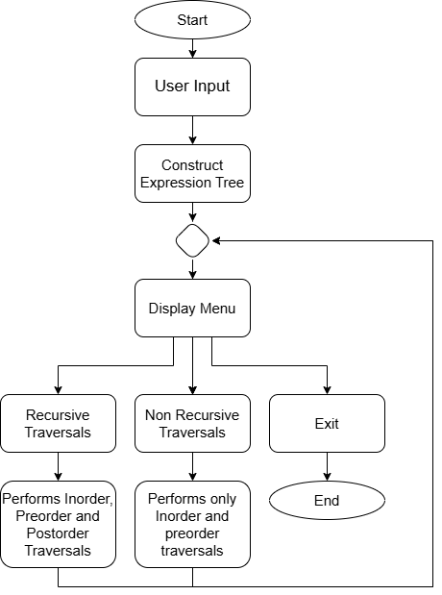
Fig 1.1 – Program Flow

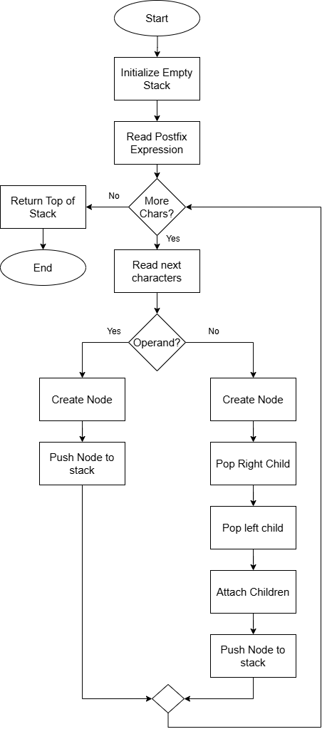
Fig 1.2 – Construct Tree

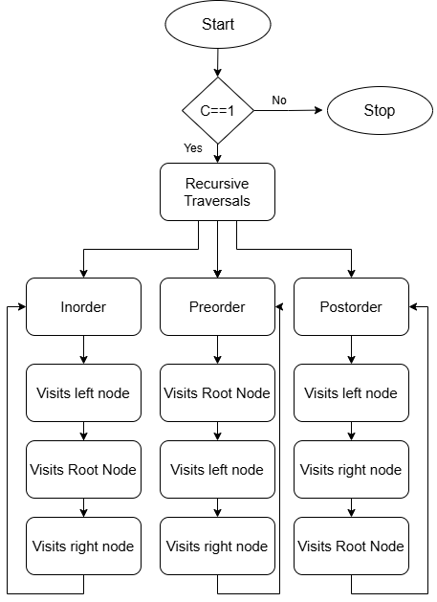
Fig 1.3 – Recursive Traversals

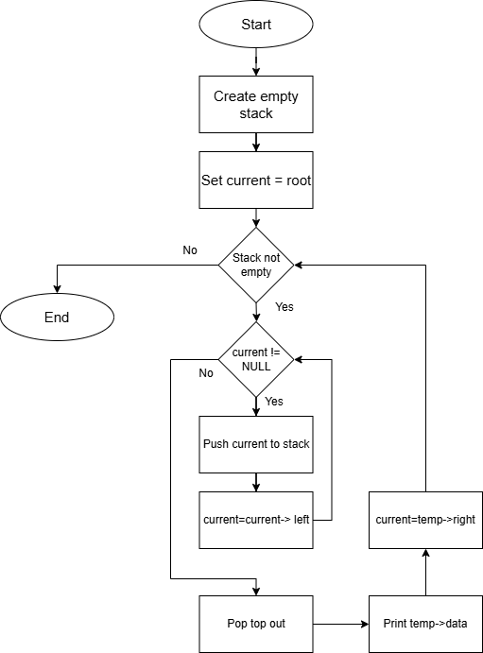
Fig 1.4 – Non-Recursive Inorder Traversal

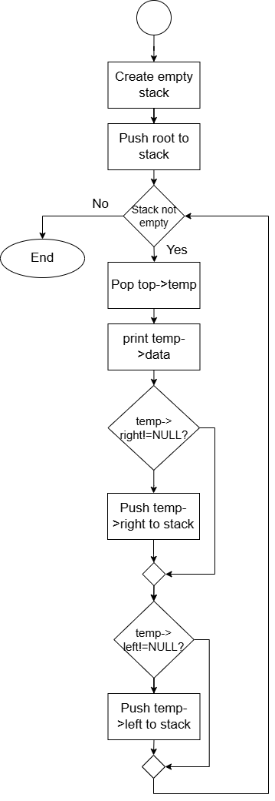
Fig 1.5 – Non-Recursive Preorder Traversal

Codes:
ExpressionTree.cpp
#include<iostream>
#include<stack>
#include <cctype>
using namespace std;

struct Node{
char data;
Node* l;
Node* r;
};
Node* create(char data){
Node* root=new Node();
root->data=data;
root->l=NULL;
root->r=NULL;
return root;
}
void inorder(Node* root){
if(root!=NULL){
inorder(root->l);
cout<<root->data<<" ";
inorder(root->r);
}
}
void preorder(Node* root){
if(root!=NULL){
cout<<root->data<<" ";
preorder(root->l);
preorder(root->r);
}
}
void postorder(Node* root){
if(root!=NULL){
postorder(root->l);
postorder(root->r);
cout<<root->data<<" ";
}
}
Node* constructTree(string exp){
stack<Node*> st;
for(int i=0;i<exp.length();i++){
if(isalnum(exp[i])){
Node* root=create(exp[i]);
st.push(root);
}else{
Node* root=create(exp[i]);
root->r=st.top();
st.pop();
root->l=st.top();
st.pop();
st.push(root);
}
}
return st.top();
}
void inorderNR(Node* root){
stack<Node*> st;
Node* a=root;
while(a!=NULL || !st.empty()){
while(a!=NULL){
st.push(a);
a=a->l;
}
Node* temp=st.top();
st.pop();
cout<<temp->data<<" ";
a=temp->r;
}
}
void preorderNR(Node* root){
stack<Node*> st;
st.push(root);
while(!st.empty()){
Node* temp=st.top();
st.pop();
cout<<temp->data<<" ";
if(temp->r!=NULL){
st.push(temp->r);
}
if(temp->l!=NULL){
st.push(temp->l);
}
}
}
int main(){
string exp;
int c=0;
cout<<"Enter postfix expression: "<<endl;
cin>>exp;
Node* root = constructTree(exp);
while(c!=3){
cout<<"Menu :"<<endl;
cout<<"1. Recursive Traversals"<<endl;
cout<<"2. Non-Recursive Traversals"<<endl;
cout<<"Enter your choice: "<<endl;
cin>>c;
switch(c){
case 1:
cout<<"Recursive Traversals"<<endl;
cout<<"Inorder: "<<endl;
inorder(root);
cout<<endl;
cout<<"Preorder: "<<endl;
preorder(root);
cout<<endl;
cout<<"Postorder: "<<endl;
postorder(root);
cout<<endl;
break;
case 2:
cout<<"Non-Recursive Traversals"<<endl;
cout<<"Inorder: "<<endl;
inorderNR(root);
cout<<endl;
cout<<"Preorder: "<<endl;
preorderNR(root);
cout<<endl;
break;
case 3:
cout<<"Bye Bye"<<endl;
return 0;
default:
cout<<"Invalid Choice!"<<endl;
break;
}
}
}

Outputs:
Expression Tree Traversals
